Report

Name: Saloni Parekh

Project: Restaurant website (frontend only)

I learned HTML and CSS along with a bit of bootstrap while making this project.

Work Flow:

In the first two weeks I did Html and added a bit Css to it and in the later two weeks the remaining Css and bootstrap was added.

No coursera or udemy courses were taken.

Screenshots:

HOME PAGE

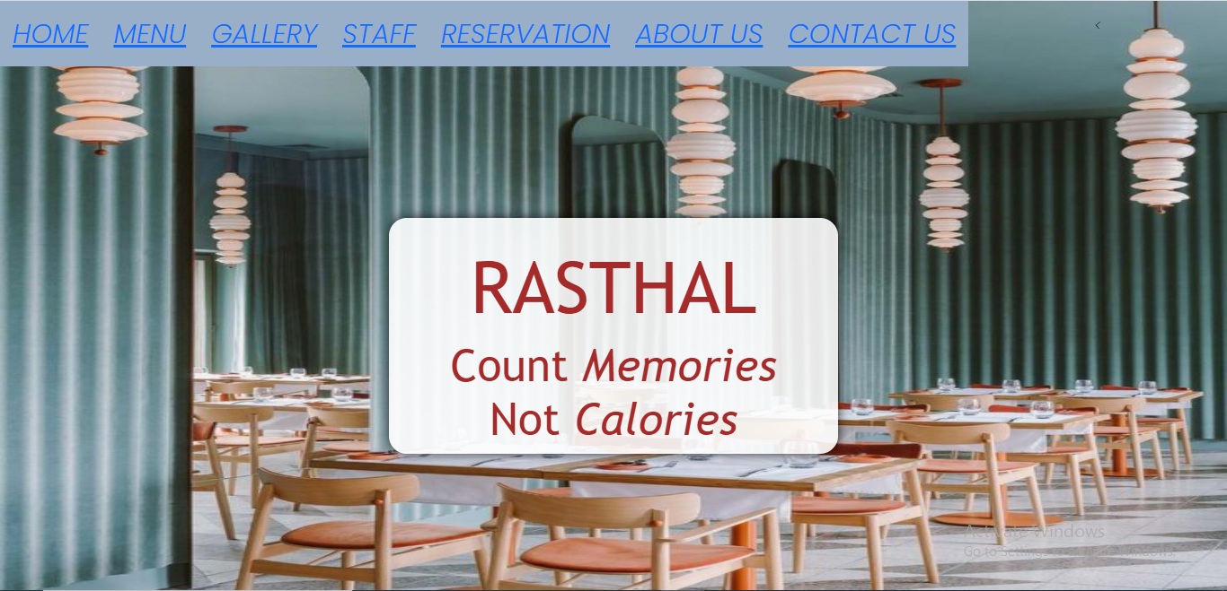

MENU PAGE:

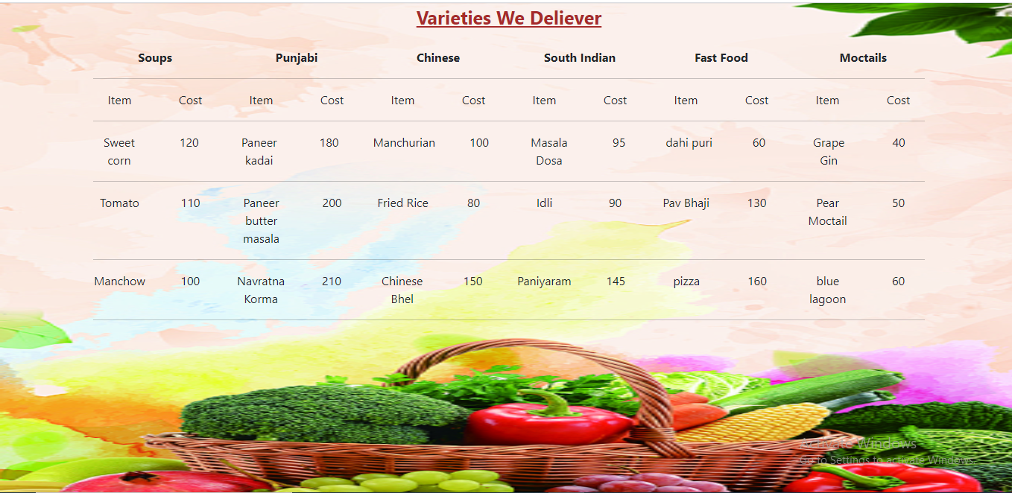

GALLERY PAGE

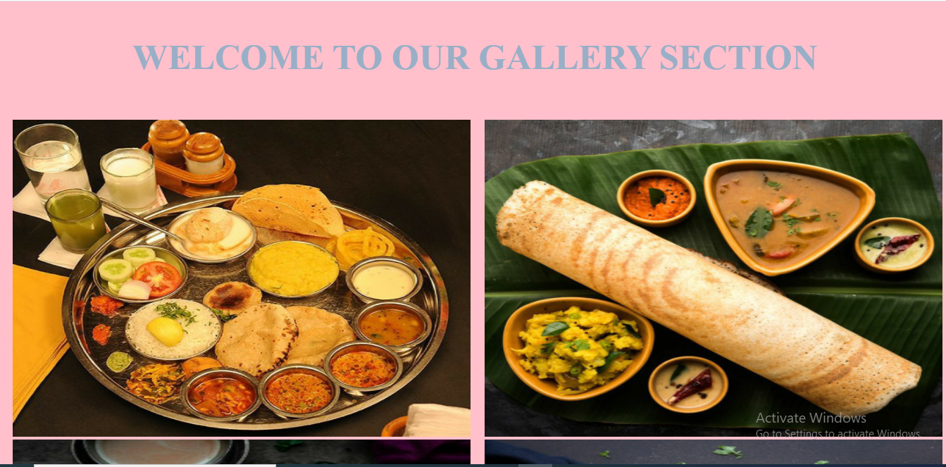

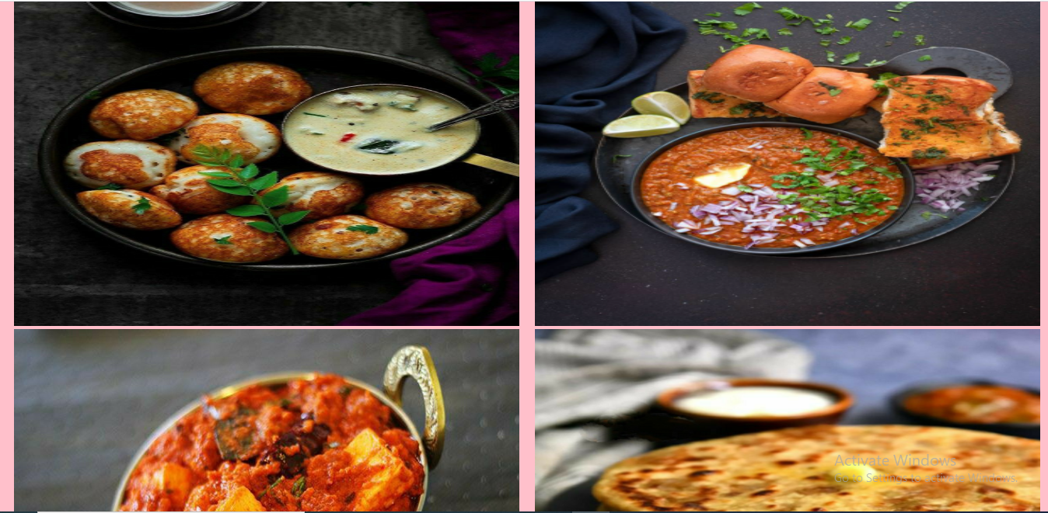

STAFF PAGE

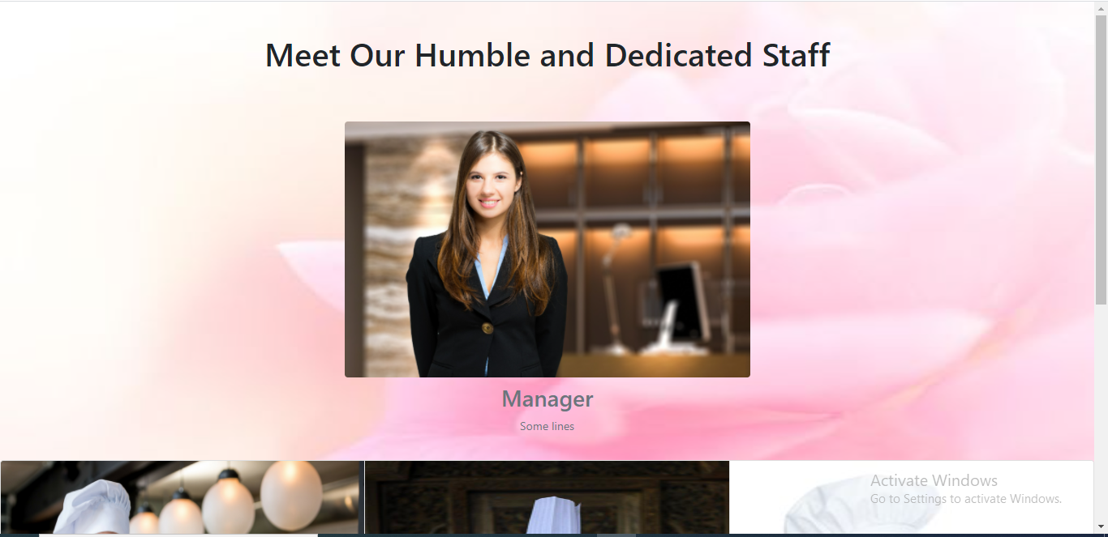

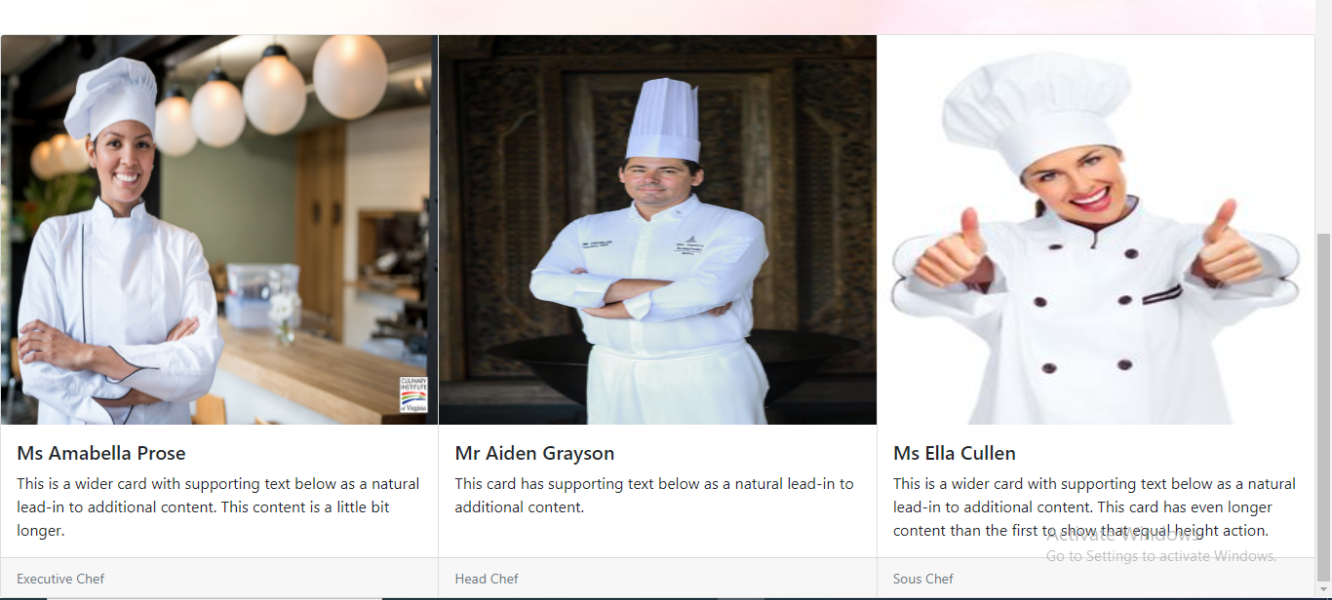

RESERVATION PAGE:

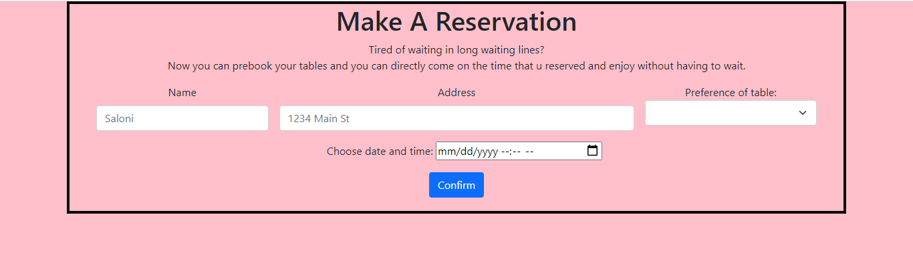

ABOUT US PAGE:

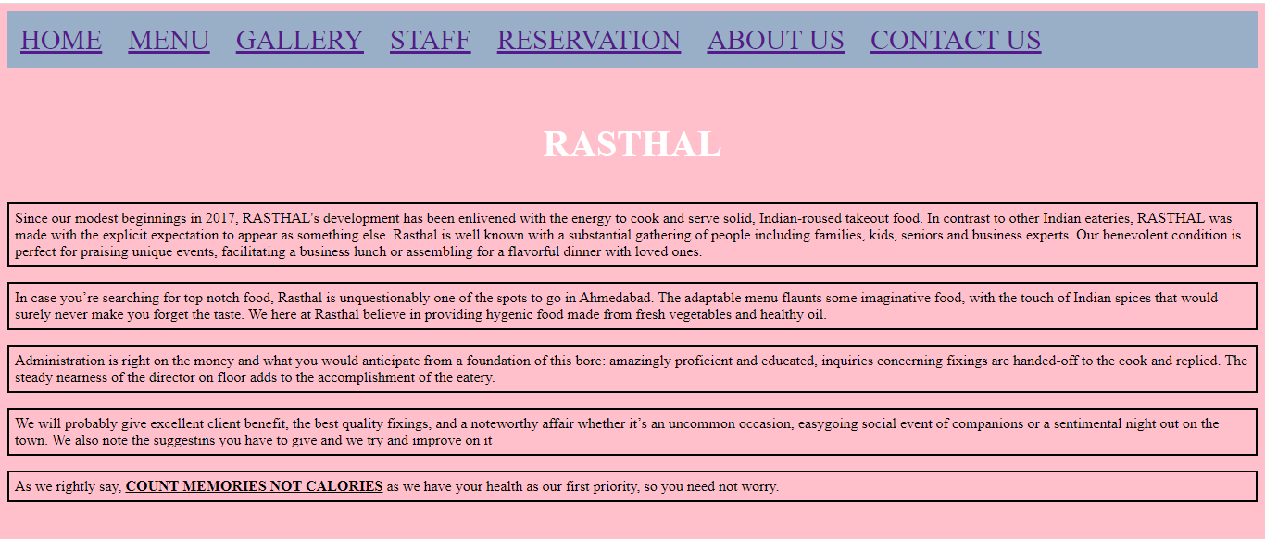

Contact us page:

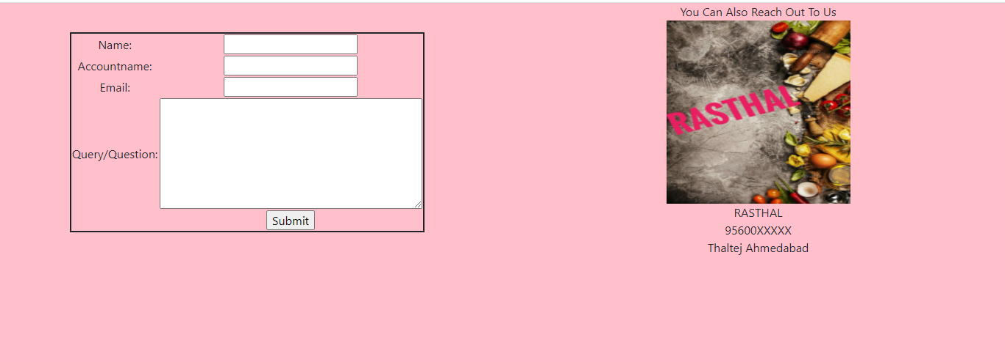

Github repo link:

<https://github.com/saloni15495/restaurant>